The 4th Fukushima Vocal Ensemble Competition 2011
REGISTRATION FORM V - Stage Arrangement

■Category Competition and Grand Champion Competition
Choir Name
Category |  |  | The number of participants | Persons  （Singer, Conductor and Accompanist）
  CategoryⅠ
  CategoryⅡ
  CategoryⅢ
Musical instruments for  accompaniment
   | Unused |  |  | Piano |  |  |  | Piano(only for tuning)
   | Cembalo |  |  | Positive Organ |  |  |  | Pipe Organ
   | Musical instruments to be brought with you
Piano Lid
   | Closed |  |  | A little Opened
   | Half Opened |  |  | Fully Opened | (Not Removed)
Do you need a chair for a person to turn the pages of notes? |  | Yes |  | No

Do you need a podium? |  | Yes |  | No

Do you need a music stand? |  | Yes |  | No

Chart requested for arrangement of the stage
1 Mark ○ for position of singers.
2 Circle the piano A, B or C for arrangement of the piano.
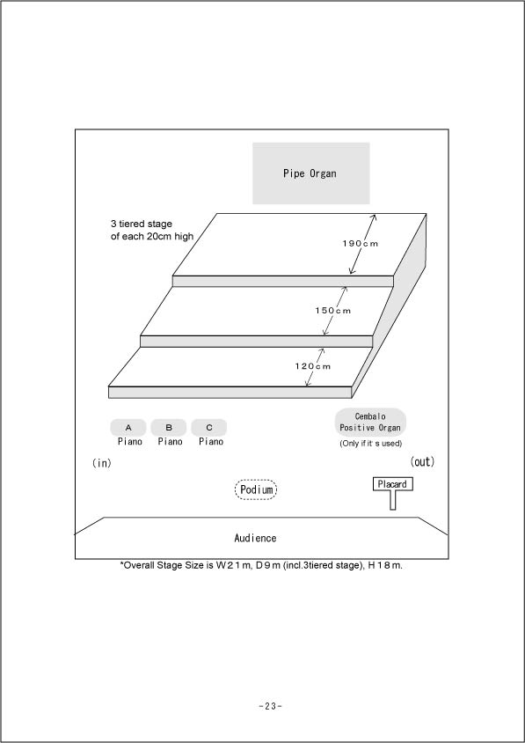

Piano Position

A: Wing of the stage

B:Left side of the
performers on the left
from the audience seat

C: Nearby the left side of
the conductor
(*Not moved to the center
of the stage.)

*If the piano is used only for
tuning, its position is fixed
to A.

*Positions of other musical
instruments will be fixed.

■Friendship Concert
Choir Name
Category |  |  | The number of participants | persons  （Singer, Conductor and Accompanist）
  CategoryⅠ
  CategoryⅡ
  CategoryⅢ
Musical instruments for  accompaniment
   | Unused |  |  | Piano |  |  |  | Piano(only for tuning)
   | Cembalo |  |  | Positive Organ |  |  |  | Pipe Organ
   | Musical instruments to be brought with you
Piano Lid
   | Closed |  |  | A little Opened
   | Half Opened |  |  | Fully Opened | (Not Removed)
Do you need a chair for a person to turn the pages of notes? |  | Yes |  | No

Do you need a podium? |  | Yes |  | No

Do you need a music stand? |  | Yes |  | No

Chart requested for arrangement of the stage
1 Mark ○ for position of singers.
2 Circle the piano A, B or C for arrangement of the piano.
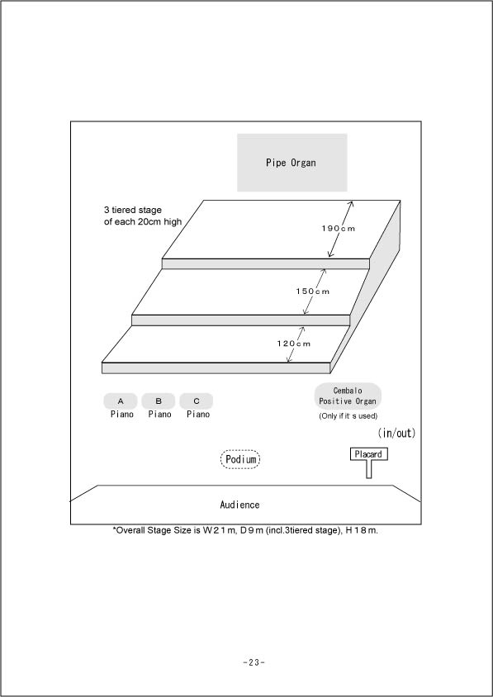

Piano Position

A: Wing of the stage

B:Left side of the
performers on the left
from the audience seat

C: Nearby the left side of
the conductor

